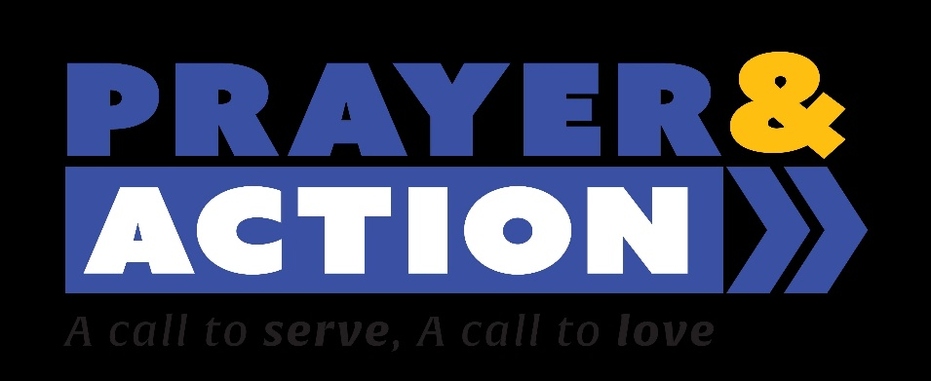

Can we please borrow; or may you donate:
- Ladders
- Paint (primer, metal primer, non-oil)
- Paint buckets, paint pails
- Paint rollers, brushes, roller trays, roller extensions
- Asbestos protection (brushes, sealer)
- Tubs (for each crew)
- Scrapers
- Chainsaws;
- Chainsaw gas containers
- Loppers and clippers, extension loppers (trimming)
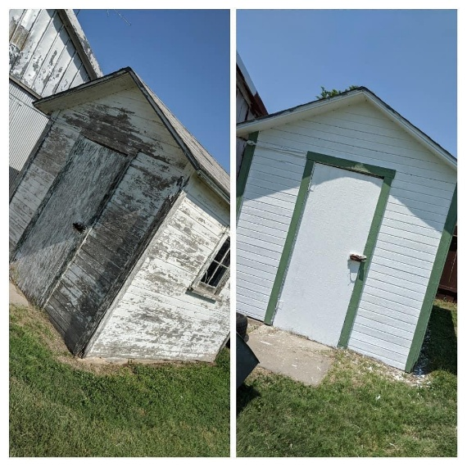
- Hammers, nails, drill
- Rakes (leaf and hard)
- Shovels
- Rags, brushes for cleaning dirt
- Painters tape
- Trash cans
- Caulking
- Wheelbarrows
- Gloves
- Trailer

Anything helps! For more information please contact Fr. Martin at the Parish Office

